Vehicle Management System project in Java
- Tuesday, November 27, 2012, 6:56
- Java Projects, Projects
- 18,660 views
Vehicle Management System is developed and customized for commercial fleet owners and organizations. Its modules support most type of vehicles (passenger, Truck, construction and other commercial vehicles). It really reduces your vehicles cost while increasing performance and dependability. Track your tax-deductible business miles and travel expenses Eliminate costly unscheduled maintenance. Increase the resale value of all your vehicles. Keep accurate records for any type of vehicle. Help you plan annual vehicle budgets faster, easier and more accurately Keep track of Party Ledgers Payment Receipt) Keep track of Driver and other employee ledgers
Project Developed in Single Servlet, with the Aim to get all request to a single servlet. I have used MySQL as a Database. You can find the database script in database folder of Donwloadable zip file.
Please feel free to post your comments about the functionality of the project. Enjoy
Features
Admin
- View/Edit/Delete Vehicle Details
- View/Edit/Delete Driver Details
- Fuel Expences/ Oil Change Details
- Vehicle Repair History
- Booking Status Detail
User Module
- Login/Registration of User
- Take a Car trip (Google Map Integration)
- View Car Details
- Car Booking
Screen Shot
Home Page
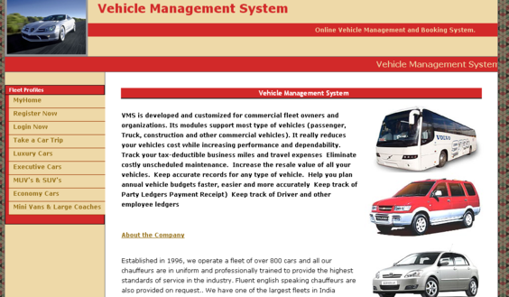
Vehicle Management – Home Page
Admin Page
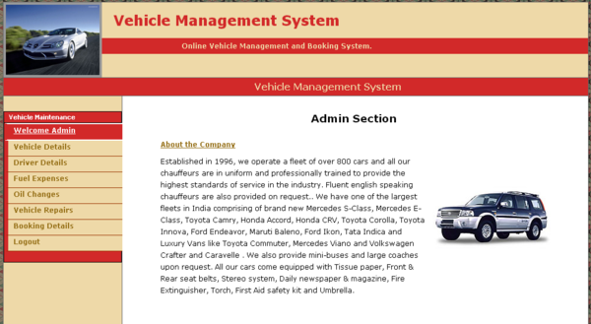
Vehicle Management – Admin
Vehicle Details
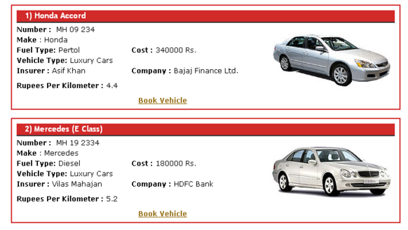

Note: This is not a commercial project, and hence not suitable for any production/ Enterprise uses. We will neither open to attend any support / enhancement request not take guarantee of any functionality.
For Support, Customization Please contact to Tousif Khan (tousifkhan510@gmail.com)

Java Projects on vehicle insurance
October 15, 2012 Java Projects

Objective of Java Projects on vehicle insurance
This is Java Projects on vehicle insurance, which provided a lot of facility to their user.
The objective and scope of my Project vehicle insurance is to record the details various activities of user. It will simplifies the task and reduse the paper work. During implementation every user will be given appropriate training to suit their specific needs. Specific support will also be provided at key points within the academic calendar. Training will be provided on a timely basis, and you will be trained as the new is vehicle insurance rolled out to your area of responsibility.
At the moment we are in the very early stages, so it is difficult to put a specific time on the training, but we will keep people informed as plans are developed.The system is very user friendly and it is anticipated that functions of the system will be easily accessed by administrators, academics, students and applicants.
Hence the management system for the College management has been designed to remove all the deficiency from which the present system is suffering and to ensure.

Abstract of vehicle insurance
The client uses MS Excel, and maintains their records, however it is not possible them to share the data from multiple system in multi user environment, there is lot of duplicate work, and chance of mistake. When the records are changed they need to update each and every excel file. There is no option to find and print previous saved records. There is no security; any body can access any report and sensitive data, also no reports to summary report. This vehicle insurance is used to overcome the entire problem which they are facing currently, and making complete atomization of manual system to computerized system.

The main limitation of the previous system of vehicle insurance:
- The existing system only provides text-based interface, which is not as user-friendly as Graphical user Interface.
- Since the system is implemented in Manual, so the response is very slow.
- The transactions are executed in off-line mode, hence on-line data capture and modification is not possible.
- Off-line reports cannot be generated due to batch mode execution.
Hence, there is a need of reformation of the system with more advantages and flexibility. The vehicle insurance eliminates most of the limitations of the existing software. It has the following objectives:

Enhancement:
The main objective of vehicle insurance is to enhance and upgrade the existing system by increasing its efficiency and effectiveness. The software improves the working methods by replacing the existing manual system with the computer-based system.

Automation:
The vehicle insurance automates each and every activity of the manual system and increases its throughput. Thus the response time of the system is very less and it works very fast.

Accuracy:
The vehicle insurance provides the uses a quick response with very accurate information regarding the users etc. Any details or system in an accurate manner, as and when required.

User-Friendly:
The software vehicle insurance has a very user-friendly interface. Thus the users will feel very easy to work on it. The software provides accuracy along with a pleasant interface.Make the present manual system more interactive, speedy and user friendly.

Availability:
The transaction reports of the system can be retried as and when required. Thus, there is no delay in the availability of any information, whatever needed, can be captured very quickly and easily.

Maintance Cost:
Reduce the cost of maintenance.

PROJECT CATEGORY: Relational Database Management System (RDBMS)
The project is entitled “vehicle insurance”,category “RDBMS”. Hence before discussing any thing about the project vehicle insurance, a brief disscussion of related basic concept is necessary.
As a software developer or as a programmer,we are expected to design and develope any program that works correctly, efficiently and the time is easy to be used by every person, who may or may not be well versed wiht computer and its capabilities.
The Project is based on the vehicle insurance, Being the Information System it requires extensive use of some Data base Management System to store, manipulate and handle the huge and complex record, In RDBMS we can act various attributes with the database like editing the records, Modifications Deletions of the records, View the records in various formats, listing the database etc. Project can be categorized by their functioning and relation with their database and other tools can categorize project. Since this project has been developed based on the Relation Data Base Management System So Proposed system comes under RDBMS (Relational Database Management System) category, as there is need to store and manipulate a huge amount of data related to patients as per various queries.

SYSTEM DESIGN(Introduction)
The systems objectives outlined during the feasibility study serve as the basic from which the work of system design is initiated. Much of the activities involved at this stage is of technical nature requiring a certain degree of experience in designing systems, sound knowledge of computer related technology and through understanding of computers available in the market and the various facilities provided by the vendors. Nevertheless, a system cannot be designed in isolation without the active involvement of the user. The user has a vital role to play at this stage too. As we know that data collected during feasibility study wills we utilized systematically during the system design. It should, however be kept in mind that detailed study of the existing system is not necessarily over with the completion of the feasibility study. Depending on the plan of feasibility study, the level of detailed study will vary and the system design stage will also vary in the amount of investigation that still needs to be done. This investigation is generally an urgent activity during the system. Sometimes, but rarely, this investigation may form a separate stage between feasibility study and computer system design. Designing a new system is a creative process, which calls for logical as will as lateral thinking. The logical approach involves systematic moves towards the end product keeping in mind the capabilities of the personnel and the equipment at each decision making step. Lateral thought implies encompassing of ideas beyond the usual functions and equipment. This is to ensure that no efforts are being made to fit previous solutions into new situations.

System Design Considerations
The system design process is not a step-by-step adherence of clear procedures and guidelines. Though, certain clear procedures and guidelines have emerged in recent days,But still much of design work depends on knowledge and experience of the designer.When designer starts working on system design, he will face different type of problems. Many of these will be due to constraints imposed by the user or limitations of the hardware and software available in the market. Sometimes, it is difficult to enumerate the complexity of the problems and solutions there of since the variety of likely problems is so great and no solutions are exactly similar. However, following considerations should be kept in mind during the system designing phase:

Design Objectives
The primary objective of the design of course, is to deliver the requirements as specified in the feasibility reports. In general the following design objectives should be kept in mind.

Practicality
The system must be stable and can be operated by people with average.

Efficiency
This involves accuracy, timeliness and comprehensiveness to the system output.

Cost
It is desirable to aim for a system with a minimum cost subject to the condition that it must satisfy all the requirements.

Flexibility
The system should be modifiable depending on the changing needs of the user. Such modifications should not entail extensive reconstructing or recreation of software. It should also be portable to different computer systems.

Security
This is very important aspect of the design and should cover areas of hardware reliability, fall back procedures, physical security of data and provision for detection of fraud and abuse.
System design involves first logical design and then physical construction of the system. The logical design describes the structure and characteristics of features, like the outputs, inputs, files, database and procedures. The physical construction, which follows the logical design, produces actual program software, files and a working system.

Major System Design Activities
Several development activities are carried out during structured design. They are database design, implementation planning, system test preparation, system interface specification, and user documentation.

Database design
This activity deals with the design of the physical database. A key is to determine how the access paths art to be implemented.
Program design: In conjunction with database design is a decision on the programming language to be used and the flowcharting, coding, and debugging procedure prior to conversion. The operating system limits the programming languages that will run of the system.
System and program test preparation. Each aspect of the system has a separate test requirement. System testing is done after all programming and testing completed the test on system and program test requirements become a part of design specifications a prerequisite to implementation.
In contrast to the system testing is acceptance testing, which puts the system through a procedure design to convince the user that the proposed system will meet the stated requirements. Acceptance testing is technically similar to system testing but politically it is different.

Design Process
The computer system design process is an exercise of specifying how, the system will work. It is an iterative process, which is based on what the system will be do as shown in the feasibility report.Mainly, following five parts have been included in the system design process

Output Design
The starting point of the design process is the proper knowledge of system requirements which will normally be converted in terms of output.

Input Design
Once the output requirements have been finalized, the next step is to find out what data need to be made available to the system to produce the desired outputs. The basic documents in which these data are available need to be identified. If necessary, these documents may have to be revised or new documents may have to be introduced.

File Design
Once the input data is captured in the system, these may to be preserved either for a short or long period. These data will generally be stored in files in a logical manner. The designer will have to devise the techniques of storing and retrieving data from these files.

Procedure Design
This step involves specifications of how processing will be performed. In this, there are two aspects:

Computer Procedure
The computer procedure will specify what functions will be carried out on computer, what will be different programs and in what sequence the programs will be run.

Non-computer procedure
The non-computer procedure will specify the manual procedures for feeding input data, receiving outputs etc.

Control Design
The control design indicates necessary procedures which will ensure correctness of processing, accuracy of data, timely output etc. this will ensure that the system is functioning as per plan.

Development and Deployment Design
Major responsibilities include system Requirement Study, Preparing System Design Document, Preparing the Program (Form) Specs, Peer Review of the Specs, Implement Quality procedures as per the QMS Document, Documentation of SRS Revalidation & Design Documents, thorough grasping of the user functionality and applying, approving the same in the project, Developing, Testing & Debugging of Forms, User Training and Implementation of the module.

INPUT DESIGN(Introduction)
Once the analysis and design of the system has been done, it would be necessary to identify the data that are required to be processed to produce the outputs. Input is one of the most expensive phases of the operation of a computerized system and creates sometimes a major problem. Different type of problem with a system can usually be traced back to faulty input design method needless to say, therefore, that the input data are the lifeblood of a system and have to be analyzed and designed with utmost care and consideration. Input design features can ensure the reliability of the system and generate correct reports form the accurate data. The input design also determines whether the user can interact efficiently with the system.

Elements of Input Data
Inaccurate input data are the most common cause of errors in data processing. Errors entered by data entry operators can be controlled by input design. Input data are collected and organized into groups of similar data. Once identified, appropriate input media are selected for processing.

Input Data
The goal of designing input data is to make data entry as easy, logical and error free from errors as possible. In entering data, operators need to know the following:
- The allocated space for each field.
- Field sequence, which much match that in the source document.
- The format in which data fields are entered for example, filling out the date field is required through the edited format mm/dd/yy.
- When we approach input data design, we design the source document. Let us elaborate on each step.

Source Documents
Source data are captured initially on original paper or a source document. For example, a cheque written against an account is a source document. When it reaches the bank, it is encoded with special magnetic ink character recognition so that a reader that is part of the information system of the bank can process it. Therefore, source documents initiate a processing cycle as soon as they are entered into the system. Source documents may be entered into the system from punch cards, from diskettes, or even directly through the keyboard.
A source document should be logical and easy to understand. Each area in the form should be clearly identified and should specify for the user what to write and where to write it.A source document may or may not be retained in the proposed system. Thus, each source document may be evaluated in terms of.Its continued use in the proposed system,The extent of modification for the proposed system & Replacement by an alternative source document.

Input Design Guidelines
The design of input play very significant role in getting the correct output. It covers al phases of input from creation of initial data (original recording) to actual entering the data to the system for processing. The input design is the link that ties the information system into the world of its users. Some features of design may vary depending on whether the system is batch-oriented or on-line. Here, we will discuss the various objectives of input design. They focus on:
- Controlling amount of input
- Avoiding delay
- Avoiding errors in data
- Avoiding extra steps
- Keeping the process simple

Each of the five objectives of input design is briefly discussed below:

Controlling Amount of Data
An effective design controls the quantity of data for input for the following reasons:
Firstly, data preparation and data entry operations depend on people. Since labor costs are high, the cost or preparing and entering data is also high. It is quite evident, then that reducing data requirements mean lowering costs through reduced labor expense.
Secondly, the input phase of computing can be slow process and take many times longer than that needed by computers to carry out their tasks. In fact, the computer itself may sit idle until data is prepared and input for processing. By reducing input requirements, the analyst will speed the entire process from data capture to processing to provide result to users.

Avoiding Delay
When processing is delayed owing to data preparation or data entry, the cause is called a bottleneck. Avoid bottlenecks when designing input should always be one of the objectives of the analyst.

Avoiding Errors in Data
The third objective deals with errors. In one sense, the rate at which errors occur is dependent on the quantity of data. Since the lower the amount of data is inputted, there are fewer opportunities for the error to occur.
Firstly, the analyst can reduce this number by reducing the volume of data dust must be entered for each transaction.
Secondly, the analyst can also affect error rates of an operation through design. The manner in which data must be entered can reduce the chance of errors.
Still, a third aspect of error control is the need to detect errors when they do occur. Checks and balances in the data entry programs, called input validation techniques, also detect errors input.

OUTPUT DESIGN (Introduction)
Presenting the data processed by a computer-based information system in an attractive and usable form has become very essential these days’ success and acceptance of a system to some extent depends on good presentation. Therefore, system analyst must know fully how to design output report in an attractive way. Many new output devices are being introduced in the market because of recent development in computer technology. System analyst must be aware of these new technologies and try to use these new output devices if possible. Currently, excellent graphic displays are widely available. Speech output systems are also fast emerging.
There are three main reasons why outputs from the computer are required. They are:
- For communication to the persons concerned.
- For re-input to the computer for being connected with other data and further processing.
- For permanent storage.

Types of Output:
Outputs of a system can take different forms. The most common are reports, displays on screen, printed forms etc. the outputs also vary in terms of their contents, type of stationery. Frequency and timing etc. besides, due consideration also need to be given as to who will use the output and for what purpose. All these points must be kept in mind while designing outputs so that the objectives of the system are met in the best possible way.
Outputs of a data-processing system can be placed into two categories:
- Application Output
- Operating Output

Application Output
These are the outputs desired out of the system to meet its objectives. These are of three types:
- Output as a basis for decision-making. This type of output is generally required by management for decision-making purposes.
- Output as a requirement to meet a functional objective. Invoices, Excise Gate Pass, Purchase Orders are the examples of such output.
- Statutory outputs: All organization is required to produce a certain amount of reports and forms as required by law.

Operating Output
These outputs are mainly generated for use of EDP staff and give various indications as to how the system operates. System logs, error messages, status indicators etc. are the examples of such output. These types of output are not concerned for the users.

SCOPE OF THE PROJECT
It may help collecting perfect management in details. In a very short time, the collection will be obvious, simple and sensible. It will help a person to know the management of passed year perfectly and vividly. It also helps in current all works relative to College. It will be also reduced the cost of collecting the management & collection procedure will go on smoothly.
The present project has been developed to meet the aspirations indicated in the modern age. An attempt has been made through this project to do all work ease & fast. It provide current add, Update, MoveNext, MovePrevious, MoveLast, Find & Delete all facilities to accomplish the desired objectives. The facility Include in this project and the suggested activities have been organized to impart knowledge & develop skill & attitude in the College official works.
- See more at: http://www.itprojectz.com/itprojectz_new/java-projects-on-vehicle-insurance/#sthash.k3DfY22d.dpuf

